Ⅱ. 服装・持ち物 Clothes and belongings
服装や持ち物は必ず清潔に保つようにしましょう。また、すべての服や持ち物には必ず名前を書いてください。
Always keep clean your child's clothes and belongings.
Also, be sure to write your child's name on all clothes and belongings.

服装 Clothes
服装の例  Examples of outfit |  | 登降園時  When the children arrive and leave the facilities | 園内  During a day at the facility
幼稚園  Kindergarten  認定こども園（教育部分）  Centers for Early Childhood Education  (education part) |  | 制服を着ます。制服がない園もあります。  Children usually wear uniforms.  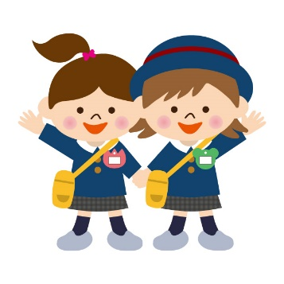  Some facilities don't have uniforms. | スモックや体操服で過ごします。  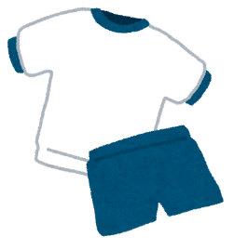  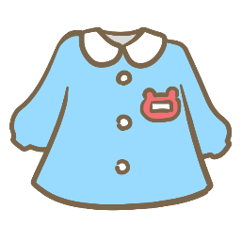  Children wear smocks or gym clothes.
保育所  Nursery school  認定こども園  (保育部分)  Centers for Early Childhood Education  (nursery part) | 乳児  0-2歳  0-2 years old | ・脱がせやすい ・着せやすい ・動きやすい 服がいいです。  Clothes that are easy to take on and off, and move are preferred.
 | 幼児  3-５歳  Toddler  3 -5 years old | スモックや制服を着ます。  制服がない園もあります。  Children wear smocks or uniforms.  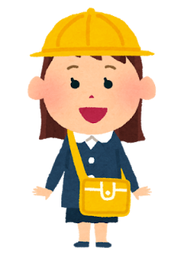  Some facilities don't have uniforms. | 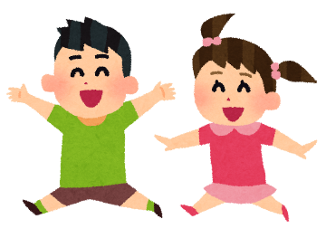  スモックや私服で過ごします。  Children spend time in smocks and casual clothes.
詳しくは、自分のお子さんを通園させる園のお知らせを確認してください。
ピアスなどのアクセサリーは、ケガや誤飲の恐れがあるため、つけないようお願いされることが多いです。
Please check a letter from the facility where your child will go.
wearing accessories is not allowed for their safety because they may be injured or accidentally swallowed.

持ち物 Things to prepare
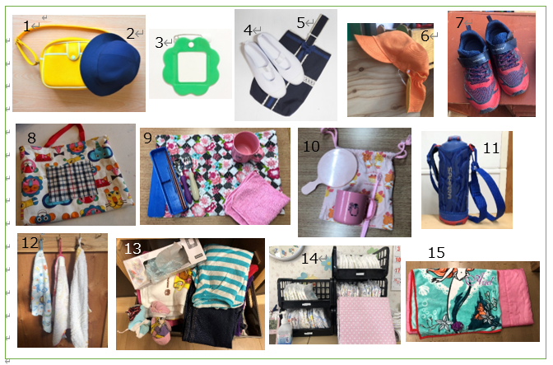
1 通園カバン 1 School bag
2 通園帽子 2 School cap
3 名札 3 Name tag
4 上履き 4 Indoor shoes
5 上履き袋 5 Shoes bag
6 カラー帽子 6 Colored hat
7 外履きの靴 7 Outdoor shoes
8 補助バッグ 8 Sub bag
9 箸セット 9 Lunch Set
10 歯磨きセット 10 Toothbrush set
11 水筒 11 Water bottle
12 ループ付きタオル 12 Towel with loop
13 予備の服・下着 13 Spare clothes and underwear
14 おむつ・おしりふき(保育所のみ) 14 Diapers and wipes (Infants only)
15 昼寝布団セット(必要な人のみ) 15 Nap Set (Only those who need it)

園では、箸セット、歯ブラシセット、水筒を洗わない場合が多いので、ご家庭で毎日洗うようにしましょう！

Most facilities don't wash chopsticks, toothbrush, and water bottles, so you should wash them at home every day！

園から服や下着を借りた時は… When you borrowed clothes or underwear from an institution,

洋服：家で洗濯して２～3日以内に先生に返しましょう。 Clothes: Washed at home and returned to teacher in a few days
下着：2通りあります。園の先生に確認してください。 Underwear: There are two ways. Please check with the teacher.
①新しいパンツを買って、２～3日以内に園の先生へ渡す。 ①Buy a new one and return it within a few days.
②洗濯して、２～3日以内に先生に返す。 ②Wash and return within a few days

