Ⅴ. の 　EDUCATIONAL SYSTEM IN JAPAN

小・中学校

Elementary/Junior high school

では（６から12までの）と（12から15の３）はで、この９はとしてどもはをけるがあります（この、どもはことはできません）。また、そのは、どもにをがあります。ではびやはなく、としてのにします。

In Japan, elementary school/SHOUGAKKOU (from 6 to 12 years of age) and junior high school /CHUUGAKKOU (from12 to 15 years of age) are compulsory education. Basically, children need to receive the school education of these 9 years (6 years of elementary school and 3 years of junior high school). During these 9 years, children are not allowed to work. Their parents or guardians have an obligation to educate their children. In 9 years of compulsory education, the students can not skip the grade or fail the grade. They will be the grade according to their age.

* これらののは、4にまり、3にわる。

School year starts in April and ends in March.

　(Age)

22.....

University



20.....

高等教育

High Education

Junior college



Specialized high school



18..... .................................

Vocational training school



High School



Secondary education school

中等教育

Lower

secondary

education

15.....

義務教育（Mandatory)

Junior High school



中等教育

学校

Compulsory education school

12..... .... .........................

Elementary School



義務教育

学校

初等教育

Elementary

education

6......　　　　　　　　　　　　　　　　　　　　　　　　　　　　　　　　　　　............................

|  |  |  |  |
| --- | --- | --- | --- |
| School | きするところ  Place of procedure | （）  How to Select a School (public) | ()  Entrance Examination (public) |
| Elementary school | City Board of Education | が  Designated by the city | なし  No |
| （）  Junior high school (Regular) | City Board of Education | が（あり）  Designated by the city  (There is a designated school change request system.) | なし  No |
| Compulsory  education school | City Board of Education | が  Designated by the city | なし  No |
| ／  Prefectural junior high school／  Secondary education school | Prefectural Board of Education | する  Where you desire | あり  Yes |
| High school | Prefectural Board of Education | する  Where you desire | あり  Yes |

**Tuition**

|  |  |  |  |  |  |  |
| --- | --- | --- | --- | --- | --- | --- |
|  | Elementary school | Junior high school | Comlusory education school | /()  Prefectural junior high school /  Secondary education school  （First semester） | ()  Secondary education school  （Second semester） | High school |
| Tuition fee | Free | | | | ではない  ※のにの  Not free  *Be eligible for state subsidies based on one's family income | |
| Textbook | Free | | | | ではない  Not free | |
| など  School supplies, etc. | ではない　　※やなどもとなります。  Not free ※ You have to pay for school lunch and school trip etc.. | | | | | |

・　Grant and Scholarship System

1. 、：「」

① Public elementary and junior high schools: they have "financial aid for school attendance" system

（おがないなど）により、（へくこと）がであるとからとき、のおやなどなが。は、やなどがあります。はをじてに。

If the Board of Education finds that the family does not have enough money to pay for school, the family can receive some help such as money for school supplies and school lunch. If you need a help, you can ask for the school you go. The school will request from the Board of Education for you.

1. ：「」

② High schools: "scholarship" system

を、にあてるためのをできます。

では、にするの（、など）をするなどがあります。

You can receive for tuition fee called “the High School Enrollment Support Fund” for both national and public schools.

In each prefecture provides scholarships for high school students. They support educational expenses (e.g. expenses for textbooks and school supplies) for low-income households.

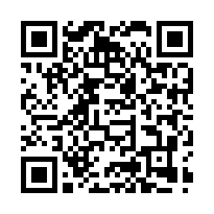はこちら　**「」**

Check here for more information “Scholarship Information of Ibaraki Prefectural Board of　Education”

https://www.edu.pref.ibaraki.jp/board/gakkou/koukou/syogakukin/index.html

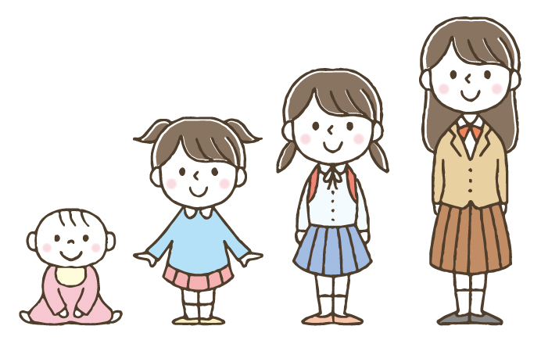

とは…

のやなどをするです。はで、もです。

にを。

**WHAT IS “THE RESERVED FUND FOR SCHOOL TRIP”...?**

It is a monthly reserve fund of the school trip such as transportation fee and accommodation fee. It is optional. You can pay in a lump sum.

Please ask the school you go to get more info.