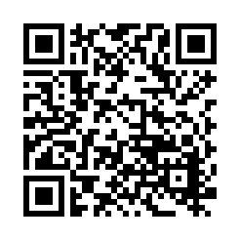

・など，きのはこちら

Check in QR code to get more information about

admission procedure when you move in/out.

「のための」

**Ibaraki International Association “Guidebook for foreign Residents”**

Ⅵ. PROCEDURE

**①　の　In case of transferring to a school**

□ ＿＿＿（○○○○課） に。

Go to ______ City Board of Education(○○department）

□ どもをさせたいことをえる。　「」をする。

Inform you desire to enter your children attend a Japanese school. Fill out “Application Form for Enrollment of Non-Japanese Students” and submit.

□「」をもらう。

Get an official admission letter for Non-Japanese Students “Gaikokujin Jidou Seito Nyuugaku Tsuuchisho”

□ されたに、のについて。

「」を(からののは、のも)する。→が。

Go to the designated school and discuss with school life of child. Submit "an official admission letter" to the elementary school. (If you moved from overseas, please submit school documents of your home country.) →Decide which grade to transfer to.

__市町村名_ City Board of Education

Address:　　住所

TEL:

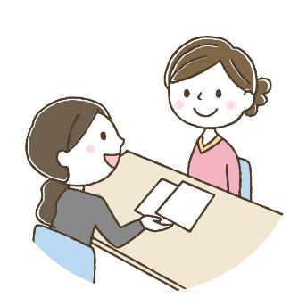

: のはどものをでめています。４２からの４１にまれたどもはじになります。のどももでがまります。もしかしたらどもはのとにならないがあります。ただし、どもがのとして、についていくことができないとされたは、にをげるがます。でされたで、のあるにすることがです。

P.S. Grades will be decided by the age of the students in Japan. The students who were born from the second of April until the first of April following year will be in the same grade. All the students including foreign children may apply. Your child may not be assigned the same grade as his/her school in their homeland. However, if a student is judged that he/she cannot keep up the class because of the language issue, he/she may be allowed to lower the grade temporary. Or he/she can change the school where Japanese class is offered.

にすること： What to confirm before entering school：

　するの　 Education history which your child had before the transfer

　　 Length of stay

　　　　　 　　The Date of the birth

　いた　　　　The grade at the prior school

　やのの　　Japanese language level of the child or the family

　やの　　　　Names of the child and his/her family members

　の　　　　　Present Address

　の　　　 Emergency contact number

　への　　　　The routes from home to school

　の　　 Health condition of child

**②（4）からする（）Procedure for regular entrance in April (Elementary School)**

は４からまりますので、のの４にへおさんをしくさせたい、んでいるののにそのをしておけば、かのがます。

School starts from April in Japan. Apply to the Board of Education where you live to enter an elementary shool, you will receive some notifications.

8 ＿＿市町村にのあるのに「」のがる。

　　までにでみをする。 ※カード，，が

August Parents or guardians will receive an application form. Fill out the form and send it to the Board of Education by the deadline. You need to bring residence card, maternity record card and hanko(Japanese stamp).

10 「の（はがき）」を、をします。

October You will receive a letter for medical checkup(SHUGAKUJI KENKOU SHINDAN NO TSUUCHI). Please fill it out your information.

11　　の。　されたにでにく。、、、などのと、なやにのが。

November Guardians with their childlen go to the elementary school which they enter for the medical checkup. The optpmetrist will check your eyes. The otolaryngologist will check yoru ears and nose. The dentist will check your teeth. Also there is the guidance to enter the primary school.

12　 「」と「」がく。のにに。

December You will receive a letter of the admission (NYUUGAKU TSUUCHISHOU) and

a letter of entering school (SHUUGAKU TSUUCHISHO).

You have to take both of them on the entrance ceremony in April.

2　　がある。

February You will have an orientation.

4　 。された、までにでに。

**：**のに。でなで。 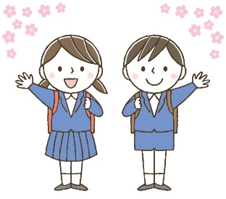

April Reception. The guardians and the new student will have to be at the school by the designated time.

**Entrance ceremony:** Go to the gym in a school. Please make sure to wear something formal (both new student and his/her guardians).

のはのみでにむかい、やののを。、、などがされます。はのに。その、はしません。

After the entrance ceremony, only new students will go to their classroom to have a class meeting about the new school year schedule. The teacher will give them their name tag (NAFUDA), textbooks(KYOKASHO) and documents(KOJINCHOSASHO).

Opening ceremony (SHIGYOSHIKI) will be held on the first day of school without parents nor guardians. It is not necessary for parents to attend the SHIGYOSHIKI.

しないと、がので、ないように。

If you don't reply, you won't get a school attendance letter, so please sign up.

A LETTER OF ENTRING SCHOOL （）

郵　便　は　が　き

〒100-000

　　　　　　　○○市○○町○-○-○

○○様

No.

**入　学　通　知　書**

令和　　年　　月　　日

保護者　様

○○市教育委員会

　　　　（○○課）

次のとおり入学されるよう通知します。

入学者名

生年月日 年 月 日 性別

入学期日 令和○○年　４ 月　１　 日

指定学校 ○○市立

**入学受付日 令和○○年　４ 月　１ 日（月）午前9時**

* 上記の宛名は、住民票上の世帯主としておりますので御了承ください。
* 裏面を御覧下さい。

中央局

**料金後納**

**郵　便**

Name of

student

Please enroll as follows.

Date of the birth

Name of the school where your child will go.

Date of the entrance to the school

Date of admission

※The addressee is based on the resident card.

※Please look at the back for the detail.