Ⅶ.中学校でな物 things YOU NEED at junior high school
お子さんがへ入る事が決まったら、学校生活や学習に必要な準備をしましょう。
下記をにしてお子さんの学校に合わせて準備して下さい。
Buy school supplies before the school starts. You can see standard school supplies which listed below. But please confirm with your school what you exactly need to buy.

a) 服装と() Clothes and belongings（EXAMPLE）
- 制服: 男女ともに，指定の夏服と冬服がある。学校から制服が売られている店舗の情報を聞くこと。
School Uniform: (SEIFUKU) There are summer clothes and winter clothes for boys and girls. Please confirm the designated school where you can buy them.
- 上履き: 学校指定 ※によって色の指定がある場合がある。
Indoor shoes (UWABAKI): indoor shoes are designated by the school
※Some junior high schools have a different shoes colour by grades.
- 名札: 進級時や紛失した時は買う。入学式の日に配布される。
Name tag(NAFUDA) will be given at the entrance ceremony.
When you lose it, you have to buy a new one.
- 通学カバン School bag (TSUUGAKU KABAN): shool backpack
体操着 学校指定のTシャツやジャージGym clothes: T-shirts and jerseys are designated by school
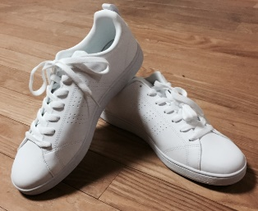
③
②
①
②②
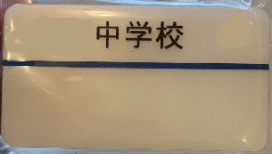
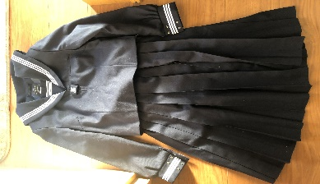
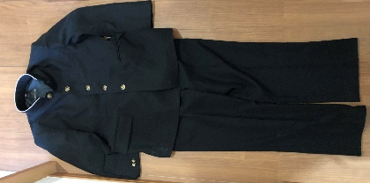

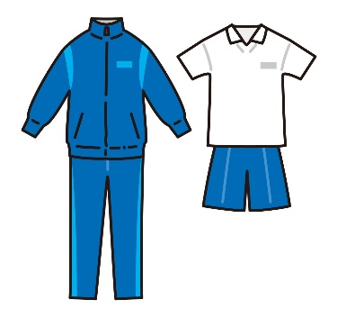
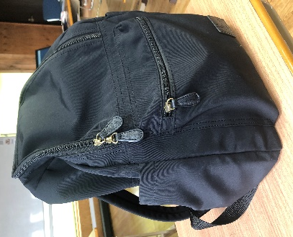
⑤
④④

②

一般的にピアス・パーマ・化粧は禁止されています。
Generally, wearing earrings, getting a perm, and makeup are not allowed.
ヒジャブなどの宗教的な配慮等が必要な場合は、学校に相談してください。
If you need religious consideration such as hijab, please tell the school.

b) 学用品 School supplies

- 各教科書は無償配布されています。 Textbooks (KYOUKASHO) are free.
- 各科目のノート Notebooks for each subject
- 文房具、筆箱、鉛筆、消しゴム、定規 など
Stationary, pencil case, pencils, erasers, rulers, etc.
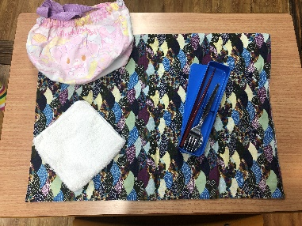
- 給食セット、ナプキン、スプーン、はし、マスク
Lunch set (KYUSHOKU SETTO) , table napkin(NAPUKIN),
spoon, chopsticks(HASHI), mask(MASUKU)

入学後に配布されるもの（一例）
These items will be handed out after entrance cereony (Example)
・生徒手帳 ・Student handbook
・ヘルメット ・Helmet
・通学用自転車許可シール ・Bicycle permission sticker

自転車通学について ○About using bicycle to school
学校に「自転車通学許可願」を提出し、登録シールをもらい、自転車に貼ります。
安全のため、自転車通学には厳しいルールが定められていますので、きちんと確認して厳守しましょう。

You need to submit "an application of using bicycle" (ZITENSYA TUUGAKU KYOKA NEGAI) to the school, get a bicycle permission sticker, and put it on your bicycle.
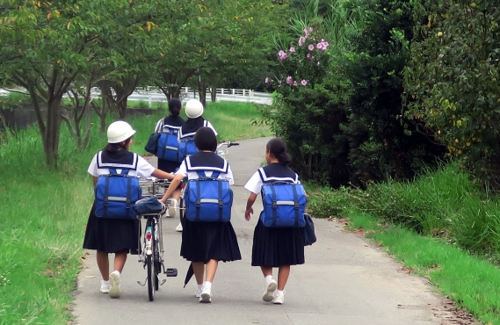
For your safety, there are strict rules for bicycle, so please make sure and follow them strictly.
15

