Ⅷ．小学校の1年間(例) ANNUAL SCHEDULE AND EVENTS OF ELEMENTARY SCHOOL(Example)
Semester | 時期  Month | 年間行事  Annual events
前期  The first semester | 4  April | 入学式･始業式 Entrance ceremony, Opening ceremony  身体測定･定期健康診断 Physical exam, Regular medical checkup  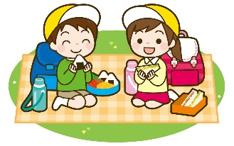  ＰＴＡ・授業参観 General meeting for Parent-Teacher Association (PTA) , Parents observation (class visit)  家庭訪問 Home visit by the teachers
 | 5  May | ＰＴＡ作業 Volunteer by PTA  遠足 Field trip
 | 6  June | 修学旅行 School trip（6のみ Only for 6th graders）  野外活動 Outdoor activities
 | 7  July | 授業参観･懇談会 Parents observation (class visit), Parents and teachers meeting
夏休み  Summer Vacation | 8月  August | 夏休み Summer Vacation
 | 9月  September | 運動会 Sports Day  終業式 Closing ceremony
後期  The second semester | 10月  October | 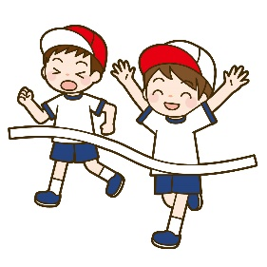  始業式 Opening Ceremony  授業参観 Parents observation (class visit)
 | 11  November | 宿泊学習 Overnight school trip  学芸会･文化祭 School play day, Culture festival
 | 12  December | 授業参観･懇談会 Parents observation (class visit), Parents and teachers meeting
冬休み
Winter vacacion
 | 1月  January | 健康診断 Medical checkup
 | 2月  February | 新入児保護者説明会 Orientation for the new students and their parents/guardians
 | 3  March | 授業参観･懇談会 Parents observation (class visit), Parents and teachers meeting  卒業式 Graduation ceremony 終了式 Closing ceremony
（２の） （In case of semester system）
各学校により、の開催時期が異なります。
The event date may be different depending on the school.

小学校の A DAY AT ELEMENTARY SCHOOL

- Going to school ( TOUKOU)
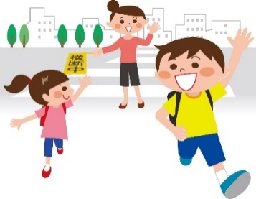
School route is already designated. There are some groups divided by where the students live. And all the group members will go to /from school together every day. This group is called (登校班 toukouhan). This means the students get together at a certain time. They go to school and come home together. The school will decide which group you would belong to.

- In case if he/she is late, absence or leave school earlier
(や･早退の場合 CHIKOKU,KESSEKI or SOUTAI)
In case if he/she is late or absent, you have to call shool or ask a classmate to bring a communication notebook ( RENRAKUCHOU) with him/her to give it to the classroom teacher. If you don’t contact to the school, the class teacher will be worried and call your house.

Leave school earlier (早退SOUTAI):
If the student leaves school early, he/she needs to ask your class teacher and gets a permission. If the student gets sick at school and needs to leave school earlier, the class teacher will contact the guardians for him/her.

- Class (JUGYOU)
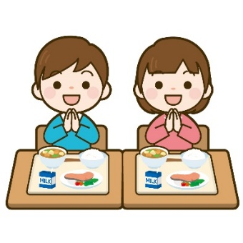
At the elementary school, a class is 45 minutes and afterwards it will be 10 minutes break. Students need to check on the class schedule (時間割 JIKAN WARI) and make sure what you need for the next class (text book, notebook, etc).

- Lunch (昼食 CHUUSYOKU)
School lunch (給食KYUSHOKU) will be given from Monday to Friday.
All the students will eat the same food except those who have restrictions.

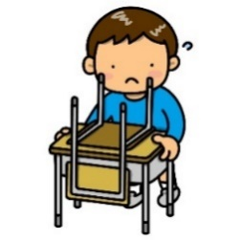
- Cleaning (掃除 SOUJI)
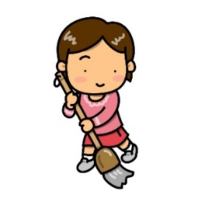
Students should clean by themselves the classrooms,
hallway, restrooms, etc. everyday.

- Meeting before going back home (帰りの会 KAERI NO KAI)
Students have a meeting before going back home. Homeroom teacher will inform about the homework, next day’s activities. Students have to take a note on their communication notebook. Please check your son/daughter’s communication notebook at home.

