Ⅸ. 保護者と関係の深い行事
MAIN EVENTS AND ACTIVITIES RELATED TO THE GUARDIANS
In Japan, parents/guardians reguraly have a meeting with the class teacher. This is a great opportunity for parents to communicate with the class teacher and get to know how his/her child is doing at school. You can ask anything such as their social skills, problems with bullying (いじめ IJIME), if he/she feels comfortable coming to school or the future of him/her.

1) Home visit by the teachers (家庭訪問 KATEI HOUMON)
During April and May, the class teacher will visit the house of each student. The teacher and parents will have a talk about how he/she is doing at school or home. It is good opportunity for the guardians/parents to get to know the class teacher. It’s about 10 to 15 minutes visit.

2) Parents observation (授業参観 JUGYOU SANKAN)
Guardians/parents will come to school and see that his/her child is learning at school.
Please read the letter from the school about the parents observation day and make sure the date and time.

3) Meeting for the Guardians (保護者会 HOGOSHA KAI)
This meeting is held to talk about student’s school life. It’s held every semester.

4) Meeting with parents, student and teacher (個人面談 KOJIN MENDAN)
This meeting /consult is among parents/guardians, student and classroom teacher. This is a good opportunity to talk about concerns. Classroom teacher will decide the date and time for the meeting/consult. In case if the parents/guardians want to talk to class teacher about something particular, they can ask the teacher to arrange the suitable date and time. Especially, the third year of junior high school is an important grade to choose a career after graduation or apply high school. Please make sure the schedule and be sure to attend a meeting.

5) Lunch box (お弁当 OBENTO)
Your son/daughter should bring a lunch box (OBENTO) when they go to a field trip or they participate activities on the weekend. Make a homemade lunch for them if it is possible.

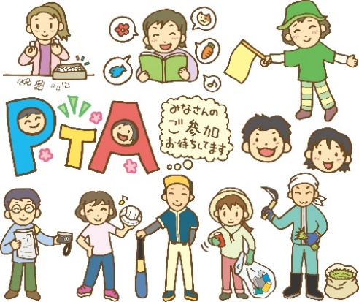
6) PTA Activity (PTA活動 PTA KATSUDO)
There is a group called the PTA (Parent-Teacher Assosiation). This group is in charge of school activities such as “Safety Guidance of School Route”,etc. It is desirable for the parents/guardians to attend PTA activity.

