問い合わせ先 ※電話の際は、まず初めに相談内容を伝えましょう。
Contact Information ※When you call them, you should tell them what you want to consult first.
相談内容 content of consultation | 相談場所 consultation place | 電話番号 Phone Number
公立幼稚園、小学校、中学校に関すること  Regarding public kindergarten, elementary school and junior high school | ＿＿＿市町村教育委員会 ○○課
保育園、認定こども園に関すること  Regarding nursery school and center for early childhood education | ＿＿＿市町村 ○○課

電話・メール相談（茨城県教育委員会委託「グローバル・サポート事業」）
Telephone and e-mail consultation service
（Entrusted by Ibaraki Prefectural Board of Education “Global support project”)
認定NPO法人 茨城NPOセンター・コモンズ Ibaraki NPO Center Commons
TEL：070-2303-7416（日本語/Japanese）／070-2303-7408（英語/English・ポルトガル語/Portuguese・タガログ語/Tagalog）
E-mail： global@npocommons.org 月曜～金曜 (Monday – Friday) 10: 00am ~ 17: 00pm

参考・関連リンク集 Reference and Related Links
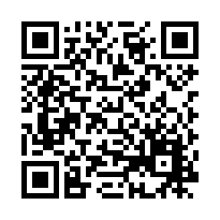
文部科学省「外国人児童生徒のための就学ガイドブック」(2015年4月発行)
Ministry of Education, Culture, Sports, Science and Technology
"School Attendance Guidebook for Foreign Students" (Published in April 2015)

https://www.mext.go.jp/a_menu/shotou/clarinet/003/1320860.htm

茨城ＮＰＯセンター・コモンズ Ibaraki NPO Center Commons
「PRE-SCHOOL」(2020) “PRE-SCHOOL”
「外国人の生活のためのガイドブック」(2019) “Guidance for International Residents”
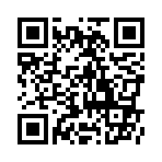
http://peer-joso.com/cn2/documents.html

茨城県教育委員会 Ibaraki Prefectural Board of Education
「子育てアドバイスブック ひよこ」 0～5歳の子をもつ保護者向け
“Parents handbook HIYOKO(chick)” For parents with 0 ~ 5 year old children
「子育てアドバイスブック クローバー」就学前～小学4年生の子をもつ保護者向け
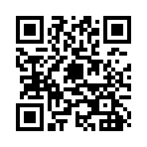
“Parents handbook KURO-BA-(clover)” For parents with preschool
~ fourth grade of elementary school students
家庭教育応援ナビ「すくすく育て いばらきっ子」からアクセス
Please access to the home education support "SUKUSUKU SODATE IBARAKIKKO".

