English

**・（）**

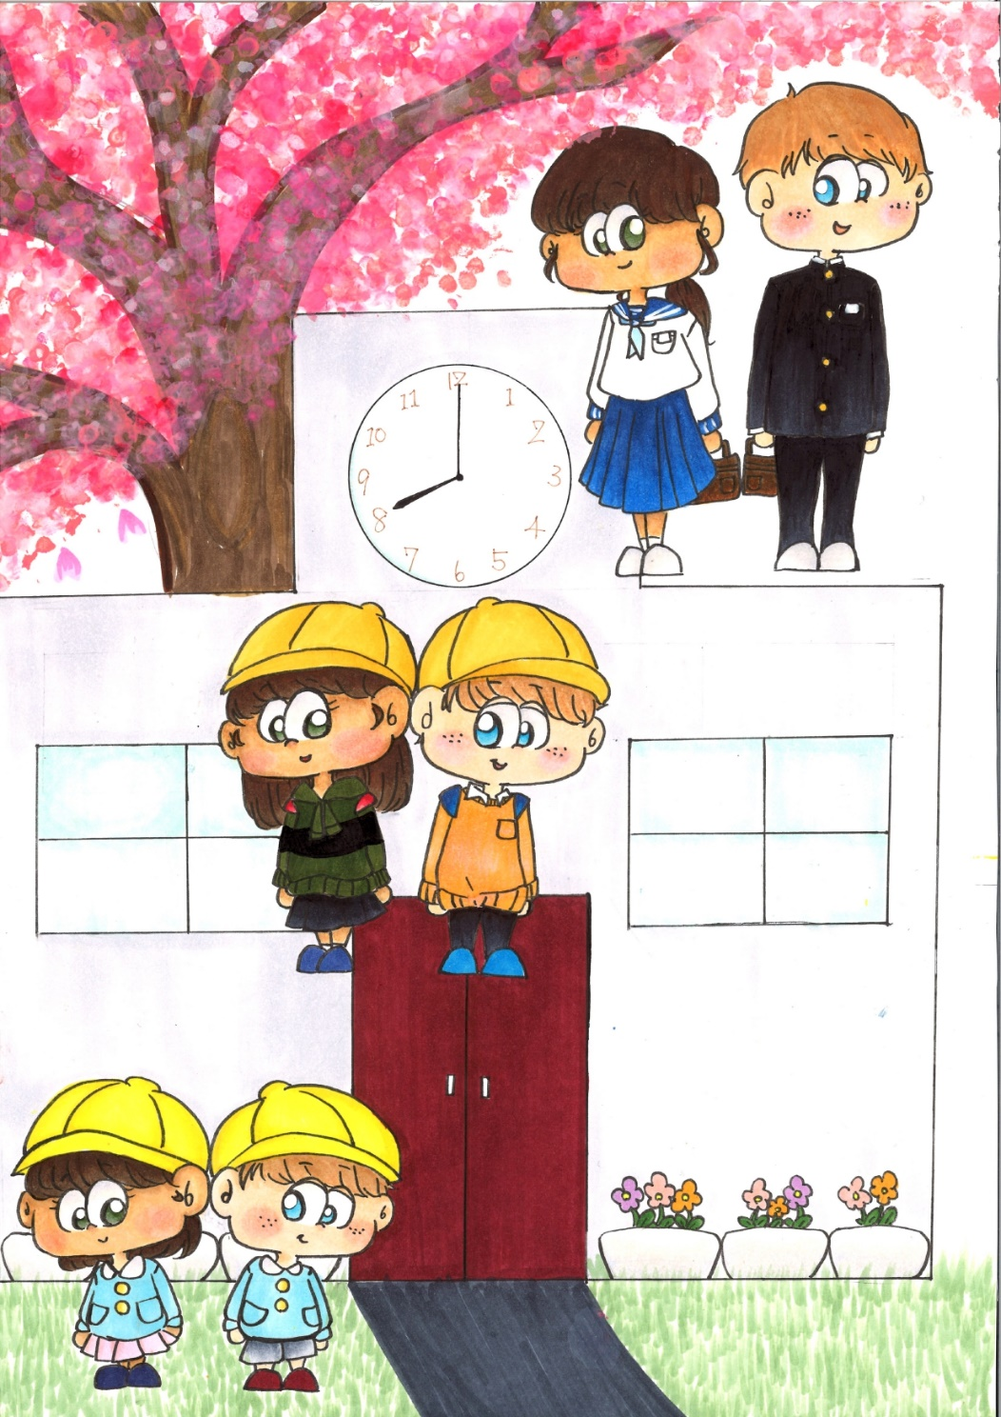

**Guidance for**

**Enrollment**

**小学校３学期制Ver.**

**Ibaraki Prefectural**

**Board of Education**

Ⅰ．のをとする　Facilities for Preschool Children

|  |  |  |  |
| --- | --- | --- | --- |
|  | Kindergarten | こども  Centers for Early Childhood Education | （む）  Nursery school  (Include community-based childcare services) |
| Target | 3からのにするまでの  Children aged from 3 and up, who have not started elementary school yet. | でのの・にかかわらず、すべての・  All children | のにより、でができない・  Children who nobody to take care at home during the day. |
| の  /  How long is the school day | 4（）  ()をしているもある。  4 hours (Standard)  Some facilities provide long hours childcare (extended child care). | ４～11  をしているもある。  4 hours ～ 11 hours  Some facilities provide extended childcare. | 8（）  11（）  やのをしているもある。  のはない。  8 hours (short-term)  11 hours (standard)  Some facilities provide after-hours childcare at night and on holidays.  There is no long vacation such as summer vacation. |
| Childcare Fee, etc. | による。  ）はに。  ）に。  It depends on kindergarten.  (Private schools) pay childcare fees to kindergartens.  (Public) Payment childcare fee to local governments. | が。  Childcare fee is decided by the founder. | のにが。  The decision is made by the mayor of the municipality depending on parents’ taxation status. |
| Jurisdiction | Ministry of Education, Culture, Sports, Science and Technology | 、、  Cabinet Office、Ministry of Health, Labour and Welfare、Ministry of Education, Culture, Sports, Science and Technology | Ministry of Health, Labour and Welfare |
| Features | でのとでのがよくえる。  You can take care of your child at home. And also children can get to know social skills at kindergarten | とののを、っている。  のになどを。  This facilities have both a nursery school and a kindergarten system.  Consultation on child will be provided to local families. | 0からことができる。  でのができないのみけれられる。  They are able to take care from 0-year-old child.  It is only accepted if the child cannot be cared for long time at home. |

１

1

をするについて３つのをいます｡

There are three categories for children who get education and childcare.

NO

YES

3 3 years and up

に

Who need childcare

に

Who needs childcare

1

Approved as No. 1

NO

2

Approved as No. 2

YES

3

Approved as No. 3

YES

のなし

Not necessary to approve

NO

・こども

Kindergarten

Centers for Early Childhood Education

・こども

Nursery school

Centers for Early Childhood Education

Centers for Early Childhood Education

にのかりが

Temporary daycare services are available as needed

**No. 1** **certification** [the process of entering Kindergarten and Centers for Early Childhood Education(education part)]　1【・こども()】のまでの

|  |  |
| --- | --- |
| の・ | Collect information on kindergartens and participate in one day pre-school |
| ・ | Information session and tour |
| が | Each facility distributes the application form |
| 、にを  (に，のいをすることがい) | Submit the application directly to the kindergarten.  In most situations you will have an interview and pay for entrance fees. |
| ，をじてへ、 | Announcement of pass. The kindergarten applies to get a certificate for you. |
| 、と | Attend an orientation. Sign a contract with a facility |
| () | Entrance ceremony |

**No. 2 ,3** **certification**[the process of entering Nursery and Centers for Early Childhood Education

(Nursery part)] 2,3【・こども()】の（）までの

|  |  |
| --- | --- |
| （＿＿＿＿課）で | Distribute application forms at city hall (__________Section) |
| ・（4（）のは11がい） | Submit and have application form screening  (In case of admission in April, it is usually around November.) |
| から（），の | Notification of results from municipalities (Issuance of certificate of approval) and determination of childcare fees |
| したい（）へしみ | Apply to the facility you want to use |
| がの、 | Municipalities coordinate and decide where to use. |
| （）と | Sign a contract with facilities |
| ，（） | Medical examination and orientation for admission |
| （） | Entrance ceremony |

2

Ⅱ.　・ち　　Clothes and belongings

やはにようにしましょう。また、すべてのやにはをください。

Always keep clean your child's clothes and belongings.

Also, be sure to write your child's name on all clothes and belongings.

◎　Clothes

|  |  |  |  |
| --- | --- | --- | --- |
| の  Examples of outfit | | When the children arrive and leave the facilities | During a day at the facility |
| Kindergarten  こども（）  Centers for Early Childhood Education  (education part) | | を。がないもあります。  Children usually wear uniforms.  ダウンロード可能】 幼稚園服 イラスト - かわいいフリー素材集 いらすとやSome facilities don't have uniforms. | やでごします。  紅白帽のイラスト（紫）体育着・体操着のイラスト園服（水色）のイラスト | かわいいフリー素材が無料のイラストレインChildren wear smocks or gym clothes. |
| Nursery school  こども  ()  Centers for Early Childhood Education  (nursery part) | 0-2  0-2 years old | ・がせやすい　・　・　がいいです。  Clothes that are **easy to take on and off**, and **move** are preferred. | |
| 3-５  Toddler  3 -5 years old | やを。  がないもあります。  Children wear smocks or uniforms.  Some facilities don't have uniforms.園服（水色）のイラスト | かわいいフリー素材が無料のイラストレイン通園バッグを掛ける幼稚園生のイラスト（女の子） | 園服（水色）のイラスト | かわいいフリー素材が無料のイラストレイン楽しそうに走る子供達のイラスト | かわいいフリー素材集 いらすとややでごします。  Children spend time in smocks and casual clothes. |

しくは、のおさんをさせるのおらせをしてください。

などのは、やのれがあるため、つけないようおいされることがいです。

Please check a letter from the facility where your child will go.

wearing accessories is not allowed for their safety because they may be injured or accidentally swallowed.

3

◎ Things to prepare

7

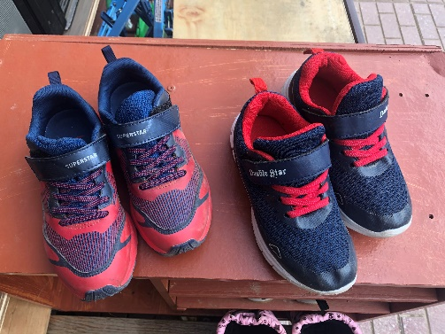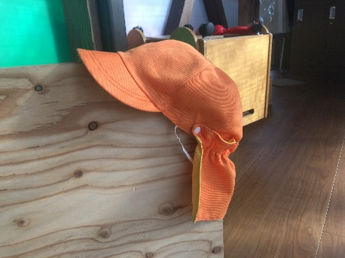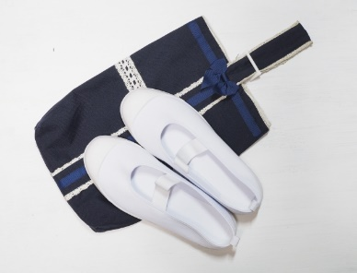

6

4

3

2

1



9

8

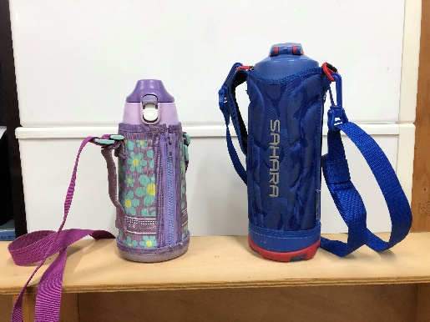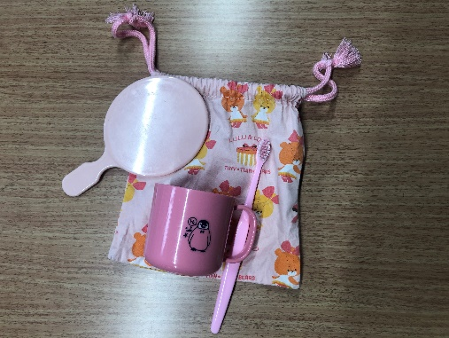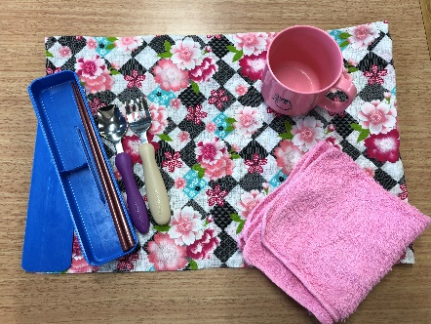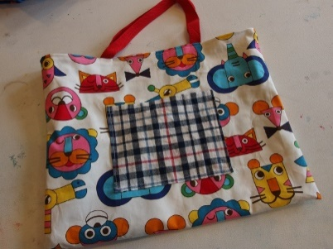

11

10

12

15

13

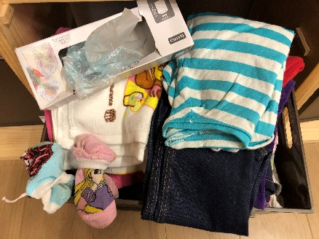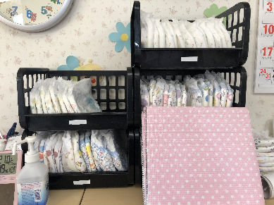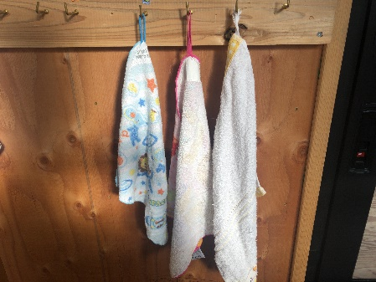

14

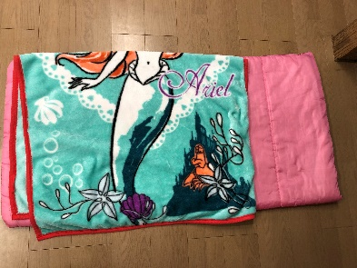

1 　　　　　　　1 School bag

2 2 School cap

3 　　　　　 3 Name tag

4 き 4 Indoor shoes

5 き 5 Shoes bag

6 6 Colored hat

7 きの 7 Outdoor shoes

8 8 Sub bag

9 9 Lunch Set

10 き 10 Toothbrush set

11 11 Water bottle

12 き 12 Towel with loop

13 の・ 13 Spare clothes and underwear

14 おむつ・おしりふき(のみ) 14 Diapers and wipes (Infants only)

15 (なのみ) 15 Nap Set (Only those who need it)

では、、、をわないがいので、ごでうようにしましょう！

Most facilities don't wash chopsticks, toothbrush, and water bottles, so you should wash them at home every day！

からやをは… When you borrowed clothes or underwear from an institution,

：でして２～3にに。 Clothes: Washed at home and returned to teacher in a few days

：2りあります。のにしてください。 Underwear: There are two ways. Please check with the teacher.

①しいをって、２～3にのへす。 　①Buy a new one and return it within a few days.

②して、２～3ににす。　　　　　　　　　　 　②Wash and return within a few days

4

Ⅲ.　との・について

How to contact facilities and pick up and drop off children

◎　In case of absence

をは、そののまでに、がでむことをください。

までにがしないと、たちはしてしまいます。

When children don’t come to the facility, the guardian have to call the facility by the morning.

Teachers get worried if their children don't come without notice.

「、 NAME OF CLASS 　 NAME OF YOUR CHILD 。

　　　　　REASON　　　　　。」

１　ねつが38℃あります。　NETSU GA 38 DO ARIMASU (He/She has a fever of 38 degree.)

２　かぜをひいている KAZE WO HIITEIRU (He/She has a cold.)

３　きもちがわるい KIMOCHI GA WARUI (He/She feels sick.)

４　けがをしました KEGA WO SHIMASHITA (He/She was injured.)

５　おなかがいたい ONAKA GA ITAI (He/She has a stomachache.)

◎する　In case of coming late

するも、とようにまでにをしてください。そのに、にするのかもましょう。

When you are coming late, please call by the morning and tell what time you will come.

「、 NAME OF CLASS 　 NAME OF YOUR CHILD 。

　　　。　TIME 　　。」

◎ Pick up and drop off your child

には、がまで、でがにくれたりします。によってがないところもあります。がするのでわせます。

At the facility, parents take children to the classroom or teachers come to pick them up by shuttle bus. Some of them don’t provide shuttle bus. You can choose the way you want.

5

◎きしのの When you leave your child

、にどもをけるに、やにかかっていることをに。

When you leave your child in the morning, please tell the teachers specifically about physical condition of your child and something you are concerned.

・いつもより　あさごはんを　たべませんでした。ITSUMOYORI ASAGOHANWO TABEMASENDESHITA.

(He/She didn't eat breakfast more than usual.)

・きのうから　げりぎみです。KINOUKARA GERI GIMIDESU. (He/She has a touch of diarrhea since yesterday.)

・よる、　せきが　でていました。YORU SEKIGA DETEIMASHITA. (He/She coughed at night.)

・いもうとと　けんかしてから　おちこんでいます。IMOUTO TO KENKASHITEKARA OCHIKONDEIMASU.

(He/She has been down since he/she quarreled with his/her sister.)

・けがを　しています。KEGAWO SHITEIMASU. (He/She got injured.)

・くすりを　もたせました。しょくごに　のませてください。

KUSURIWO MOTASEMASHITA.SYOKUGONI NOMASETEKUDASAI.

(I made him/her take medicine. Please give it after meals.)

◎の（） How to use the contact book（Example）

　　　　　はじめのいっぽ（）の　In the case of HAJIME NO IPPO HOIKUEN(multicultural nursery school)



6

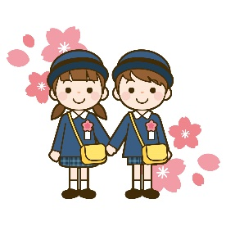Ⅳ.な　　Major events

1. Entrance ceremony ( / NYUUEN SHIKI　 / NYUUSHO SHIKI)

()は、にるどもとそのがするです。のでなわれることがいです。はスーツなど、なですることがいです。まりではありませんが、すぎないようにしましょう。

Children who enter a preschool and their parents participate in the entrance ceremony. It is usually held at the hall of the facility. Parents attend in formal clothes such as suits. It's not a rule, but please not be too casual.

1. 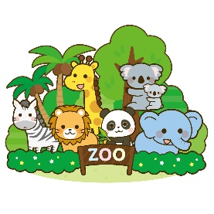Field trip (　ENSOKU)

（）をて、いやなどにでおします。などやむをないはします。おをってきます。のは、もにします。

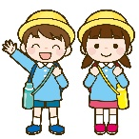Kids leave the facility with teachers and go to the park or museum. everyone will participate except unavoidable reasons such as sick. They will bring their own lunch. In the case of OYAKOENSOKU, it means parents/guardians join together.

1. Sports day (　UNDOU KAI)

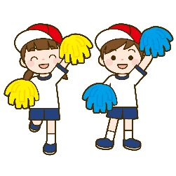は、どもたちがでったりをしたりするです。にけて、どもたちはたくさんをします。が来てくれることをしみにしています。どものをてあげてください。

Sports day is an event where children run and dance in the school playground. Children practice a lot for the sports day to show their parformance. They are looking forward to their family coming to see sports day. Please come and see your child's growth.

1. Children's recital and play day (　SEIKATSU HAPPYOUKAI)

どもたちが、にってでをしたり・をしたりします。

にてもらうために、どもたちはをってたくさんしてをえます。

のがなもありますので、のもです。

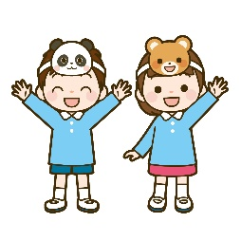Children perform a play on the stage and choral or ensemble in a class. Children practice so hard for long time to show their parents. Sometimes parents/guardians may need to prepare their costumes.

5) Graduation ceremony ( / SOTSUEN SHIKI　 / SOTSUSHO SHIKI)

（）は、どもたちがでのをしたことをい、おになったたちにおれとおをいうものです。は、（）がましいです。

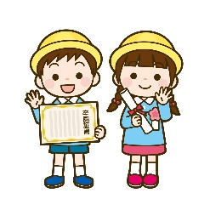The graduation ceremony is to celebrate children's graduation from preschool

and saying goodbye and thanks to teachers.

Wearing formal clothes is preferable same as the entrance ceremony.

7

Ⅴ. の 　EDUCATIONAL SYSTEM IN JAPAN

小・中学校

Elementary/Junior high school

では（６から12までの）と（12から15の３）はで、この９はとしてどもはをけるがあります（この、どもはことはできません）。また、そのは、どもにをがあります。ではびやはなく、としてのにします。

In Japan, elementary school/SHOUGAKKOU (from 6 to 12 years of age) and junior high school /CHUUGAKKOU (from12 to 15 years of age) are compulsory education. Basically, children need to receive the school education of these 9 years (6 years of elementary school and 3 years of junior high school). During these 9 years, children are not allowed to work. Their parents or guardians have an obligation to educate their children. In 9 years of compulsory education, the students can not skip the grade or fail the grade. They will be the grade according to their age.

* これらののは、4にまり、3にわる。

School year starts in April and ends in March.

　(Age)

22.....

University



20.....

高等教育

High Education

Junior college



Specialized high school



18..... .................................

Vocational training school



High School



Secondary education school

中等教育

Lower

secondary

education

15.....

義務教育（Mandatory)

Junior High school



中等教育

学校

Compulsory education school

12..... .... .........................

Elementary School



義務教育

学校

初等教育

Elementary

education

6......　　　　　　　　　　　　　　　　　　　　　　　　　　　　　　　　　　　............................

8

|  |  |  |  |
| --- | --- | --- | --- |
| School | きするところ  Place of procedure | （）  How to Select a School (public) | ()  Entrance Examination (public) |
| Elementary school | City Board of Education | が  Designated by the city | なし  No |
| （）  Junior high school (Regular) | City Board of Education | が（あり）  Designated by the city  (There is a designated school change request system.) | なし  No |
| Compulsory  education school | City Board of Education | が  Designated by the city | なし  No |
| ／  Prefectural junior high school／  Secondary education school | Prefectural Board of Education | する  Where you desire | あり  Yes |
| High school | Prefectural Board of Education | する  Where you desire | あり  Yes |

**Tuition**

|  |  |  |  |  |  |  |
| --- | --- | --- | --- | --- | --- | --- |
|  | Elementary school | Junior high school | Comlusory education school | /()  Prefectural junior high school /  Secondary education school  （First semester） | ()  Secondary education school  （Second semester） | High school |
| Tuition fee | Free | | | | ではない  ※のにの  Not free  *Be eligible for state subsidies based on one's family income | |
| Textbook | Free | | | | ではない  Not free | |
| など  School supplies, etc. | ではない　　※やなどもとなります。  Not free ※ You have to pay for school lunch and school trip etc.. | | | | | |

9

・　Grant and Scholarship System

1. 、：「」

① Public elementary and junior high schools: they have "financial aid for school attendance" system

（おがないなど）により、（へくこと）がであるとからとき、のおやなどなが。は、やなどがあります。はをじてに。

If the Board of Education finds that the family does not have enough money to pay for school, the family can receive some help such as money for school supplies and school lunch. If you need a help, you can ask for the school you go. The school will request from the Board of Education for you.

1. ：「」

② High schools: "scholarship" system

を、にあてるためのをできます。

では、にするの（、など）をするなどがあります。

You can receive for tuition fee called “the High School Enrollment Support Fund” for both national and public schools.

In each prefecture provides scholarships for high school students. They support educational expenses (e.g. expenses for textbooks and school supplies) for low-income households.



はこちら　**「」**

Check here for more information “Scholarship Information of Ibaraki Prefectural Board of

Education”

https://www.edu.pref.ibaraki.jp/board/gakkou/koukou/syogakukin/index.html

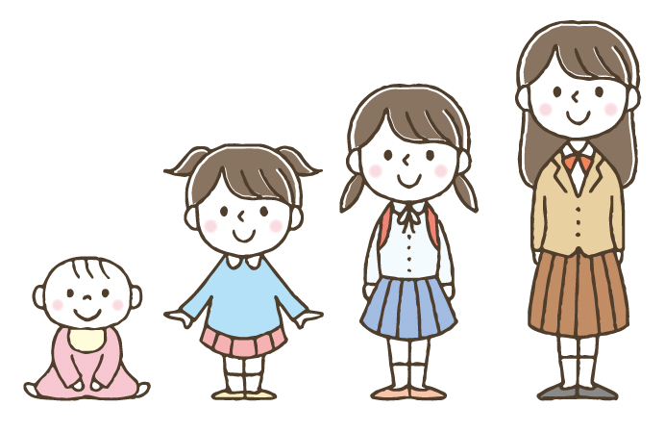

とは…

のやなどをするです。はで、もです。

にを。

**WHAT IS “THE RESERVED FUND FOR SCHOOL TRIP”...?**

It is a monthly reserve fund of the school trip such as transportation fee and accommodation fee. It is optional. You can pay in a lump sum.

Please ask the school you go to get more info.

10



・など，きのはこちら

Check in QR code to get more information about

admission procedure when you move in/out.

「のための」

**Ibaraki International Association “Guidebook for foreign Residents”**

Ⅵ. PROCEDURE

**①　の　In case of transferring to a school**

□ ＿＿＿（○○○○課） に。

Go to ______ City Board of Education(○○department）

□ どもをさせたいことをえる。　「」をする。

Inform you desire to enter your children attend a Japanese school. Fill out “Application Form for Enrollment of Non-Japanese Students” and submit.

□「」をもらう。

Get an official admission letter for Non-Japanese Students “Gaikokujin Jidou Seito Nyuugaku Tsuuchisho”

□ されたに、のについて。

「」を(からののは、のも)する。→が。

Go to the designated school and discuss with school life of child. Submit "an official admission letter" to the elementary school. (If you moved from overseas, please submit school documents of your home country.) →Decide which grade to transfer to.

__市町村名_ City Board of Education

Address:　　住所

TEL:

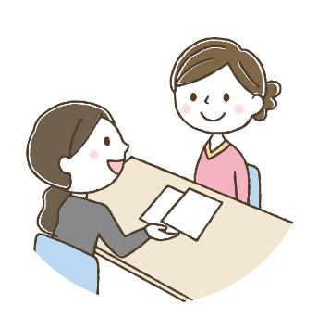

11

: のはどものをでめています。４２からの４１にまれたどもはじになります。のどももでがまります。もしかしたらどもはのとにならないがあります。ただし、どもがのとして、についていくことができないとされたは、にをげるがます。でされたで、のあるにすることがです。

P.S. Grades will be decided by the age of the students in Japan. The students who were born from the second of April until the first of April following year will be in the same grade. All the students including foreign children may apply. Your child may not be assigned the same grade as his/her school in their homeland. However, if a student is judged that he/she cannot keep up the class because of the language issue, he/she may be allowed to lower the grade temporary. Or he/she can change the school where Japanese class is offered.

にすること： What to confirm before entering school：

　するの　 Education history which your child had before the transfer

　　 Length of stay

　　　　　 　　The Date of the birth

　いた　　　　The grade at the prior school

　やのの　　Japanese language level of the child or the family

　やの　　　　Names of the child and his/her family members

　の　　　　　Present Address

　の　　　 Emergency contact number

　への　　　　The routes from home to school

　の　　 Health condition of child

**②（4）からする（）Procedure for regular entrance in April (Elementary School)**

は４からまりますので、のの４にへおさんをしくさせたい、んでいるののにそのをしておけば、かのがます。

School starts from April in Japan. Apply to the Board of Education where you live to enter an elementary shool, you will receive some notifications.

8 ＿＿市町村にのあるのに「」のがる。

　　までにでみをする。 ※カード，，が

August Parents or guardians will receive an application form. Fill out the form and send it to the Board of Education by the deadline. You need to bring residence card, maternity record card and hanko(Japanese stamp).

10 「の（はがき）」を、をします。

October You will receive a letter for medical checkup(SHUGAKUJI KENKOU SHINDAN NO TSUUCHI). Please fill it out your information.

11　　の。　されたにでにく。、、、などのと、なやにのが。

November Guardians with their childlen go to the elementary school which they enter for the medical checkup. The optpmetrist will check your eyes. The otolaryngologist will check yoru ears and nose. The dentist will check your teeth. Also there is the guidance to enter the primary school.

12　 「」と「」がく。のにに。

December You will receive a letter of the admission (NYUUGAKU TSUUCHISHOU) and

a letter of entering school (SHUUGAKU TSUUCHISHO).

You have to take both of them on the entrance ceremony in April.

2　　がある。

February You will have an orientation.

4　 。された、までにでに。

**：**のに。でなで。 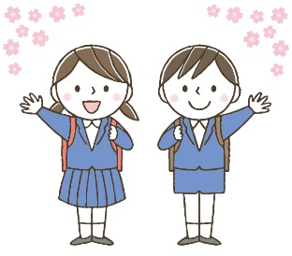

April Reception. The guardians and the new student will have to be at the school by the designated time.

**Entrance ceremony:** Go to the gym in a school. Please make sure to wear something formal (both new student and his/her guardians).

のはのみでにむかい、やののを。、、などがされます。はのに。その、はしません。

After the entrance ceremony, only new students will go to their classroom to have a class meeting about the new school year schedule. The teacher will give them their name tag (NAFUDA), textbooks(KYOKASHO) and documents(KOJINCHOSASHO).

Opening ceremony (SHIGYOSHIKI) will be held on the first day of school without parents nor guardians. It is not necessary for parents to attend the SHIGYOSHIKI.

しないと、がので、ないように。

If you don't reply, you won't get a school attendance letter, so please sign up.

12

A LETTER OF ENTRING SCHOOL （）

郵　便　は　が　き

〒100-000

　　　　　　　○○市○○町○-○-○

○○様

No.

**入　学　通　知　書**

令和　　年　　月　　日

保護者　様

○○市教育委員会

　　　　（○○課）

次のとおり入学されるよう通知します。

入学者名

生年月日 年 月 日 性別

入学期日 令和○○年　４ 月　１　 日

指定学校 ○○市立

**入学受付日 令和○○年　４ 月　１ 日（月）午前9時**

* 上記の宛名は、住民票上の世帯主としておりますので御了承ください。
* 裏面を御覧下さい。

中央局

**料金後納**

**郵　便**

Name of

student

Please enroll as follows.

Date of the birth

Name of the school where your child will go.

Date of the entrance to the school

Date of admission

※The addressee is based on the resident card.

※Please look at the back for the detail.

13

Ⅶ. でな　Things you need at elematary school

さんがへが、やになをしましょう。

をにしてさんのにして。

Buy school supplies before the school starts. You can see standard school supplies which is listed below. But please confirm with your school what you exactly need to buy.

a) と Clothes and belongings

1. ：あまりにならないような、のあるにをます。 によってはがあります。

Clothes: Wear comfortable clothes that are not too flashy. When it is P.E class, students will change to TAISOU FUKU (gym clothes). Some schools have school uniform (SEIFUKU).

1. Red-white cap (KOHAKU BOUSHI or AKASHIRO BOUSHI)
2. Bag for indoor shoes (UWABAKI IRE)
3. Indoor shoes (UWABAKI)
4. Sports shoes (UNDOUGUTSU)　へはを。

When students go to school, they wear this sports shoes.

1. やしたは。のにされます。

Name tag (NAFUDA) will be given at the day of the entrance ceremony.

When you lost it, you have to buy a new one.

1. School backpack (RANDO SERU) Some schools specify the color and/or shapes.
2. school bag (TESAGUE BUKURO)

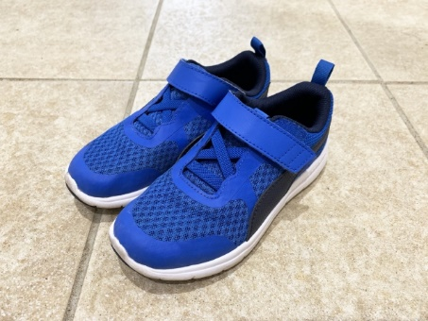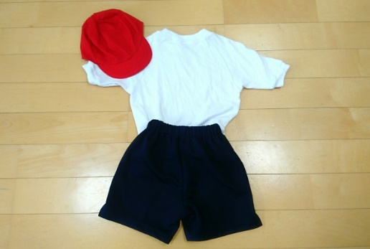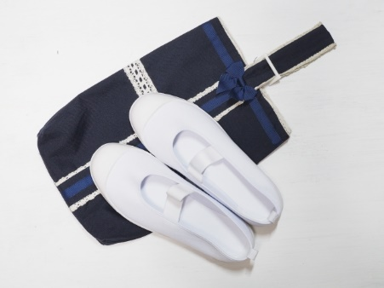

③

②

①

⑤

②

②

④

②

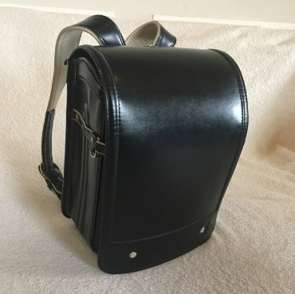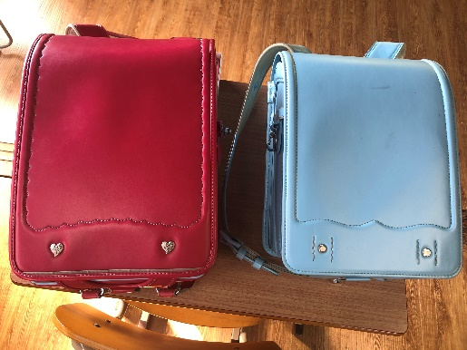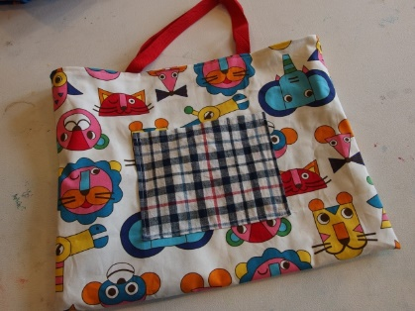

⑦

**②**

⑥

**②**

⑧

**②**

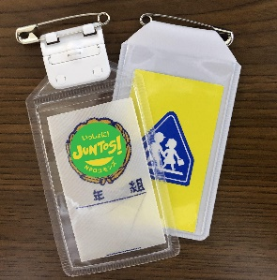

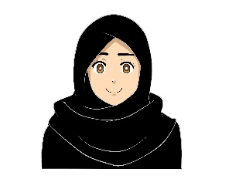・・はされています。

Generally, wearing earrings, getting a perm, and makeup are not allowed.

などのながなは、にしてください。

If you need religious consideration such as hijab, please tell to the school.

14

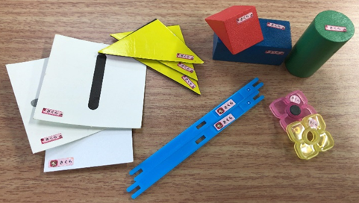b) School Supplies

* はされています。

Textbooks (KYOUKASHO) are free.

* のノート Notebooks for each subject

①セット　Arithmetic tool box (SANSUU SETTO)

**すべてにします。のを文具店やオンラインストアでするとです。**

**Write your child name on all of them. It is convenient to order name stickers at the stationary store or online store.**

②（、、、　など）　Stationary：pencil case, pencils, erasers, rulers, etc.

③お（はさみ、のり、、など）Stationary box：scissors, glue, scotch tape, stapler, etc.

④（、、はし、）

Lunch set (KYUSHOKU SETTO)：table napkin(NAPUKIN), spoon, chopsticks(HASHI), mask(MASUKU)

⑤、、: toothbrush(HABURASHI), cup(KOPPU), bag for the cup(KINCHAKUBUKURO)

⑥ Pianica (PIANIKA)

⑦　Painting set（ENOGUSETTO）

⑧、Communication book(RENRAKUCHOU), Bag for communication book(RENRAKUBUKURO)

※にでまとめてができるもあるので、のおらせをようにして！

**You might order some school supplies at the school. They will give you an order sheet, so please make sure to read all letters from the school！**

①

②②

⑧

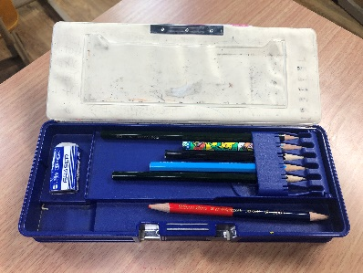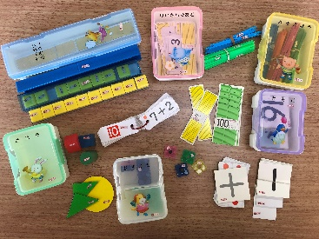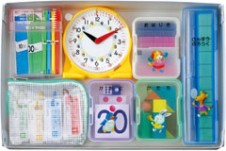

③

②

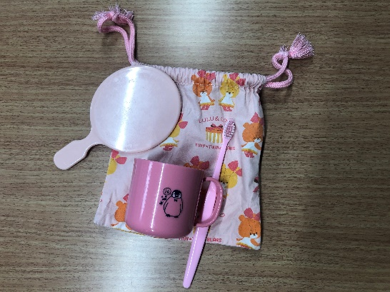

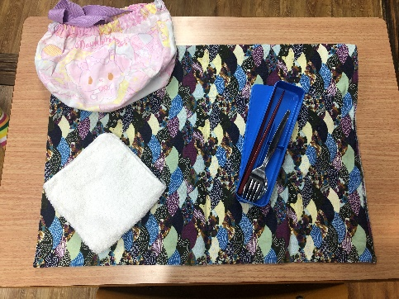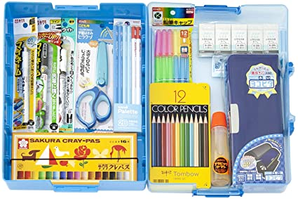

⑤

④④

②

画像：AMAZON

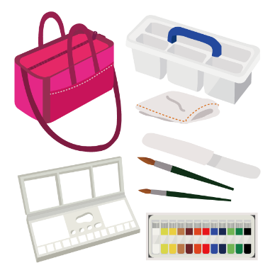

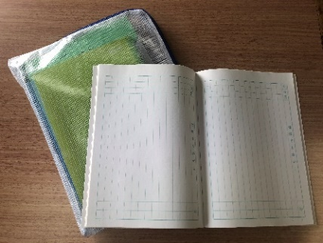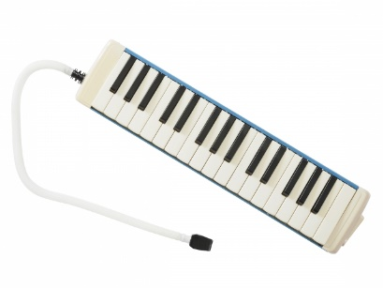

⑥

⑦

15

Ⅷ.の1() ANNUAL SCHEDULE OF ELEMENTARY SCHOOL(Example)

（３の）　（In the case of trimester system）

|  |  |  |
| --- | --- | --- |
| Semester | Month | Annual events |
| 1  1st term | 4  April | Entrance ceremony, opening ceremony  Physical exam, Regular medical checkup  ＰＴＡ　 General meeting for Parent-teacher association (PTA) , parents observation (class visit)  Home visit by the teachers |
| 5  May | ＰＴＡ　 Volunteer work by PTA  Field trip |
| 6  June | School trip（6のみ　Only for 6th graders）  Outdoor activities |
| 7  July | Parents observation (class visit), Parents and teachers meeting  Closing ceremony |
| Summer Vacation | 8  August | Summer Vacation |
| 2  2nd term | 9  September | Opening Ceremony  Sports Day |
| 10  October | Parents observation (class visit)  Field trip |
| 11  November | Overnight school trip  School playt day and culture festival |
| 12  December | Parents observation (class visit), Parents and teachers meeting  Closing ceremony |
| Winter vacacion |
| 1  January | Opening Ceremony  Medical checkup |
| 3  3rd term |
| 2  February | Orientation for the new students and their parents/guardians |
| 3  March | Parents observation (class visit), Parents and teachers meeting  Graduation ceremony  Closing ceremony |

により、のがなります。

The event date may be different depending on each school.

16

　の 　TYPICAL DAY AT ELEMENTARY SCHOOL

1. 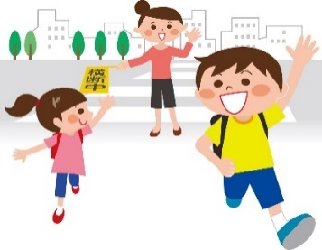Going to school　( TOUKOU)

School route is already designated. There are some groups divided by where the students live. And all the group members will go to /from school together every day. This group is called (　toukouhan). This means the students get together at a certain time. They go to school and come home together. The school will decide which group you would belong to.

1. In case if he/she is late, absence or leave school earlier

(や･の CHIKOKU,KESSEKI or SOUTAI)

In case if he/she is late or absent, you have to call shool or ask a classmate to bring a communication notebook ( RENRAKUCHOU) with him/her to give it to the classroom teacher. If you don’t contact to the school, the class teacher will be worried and call your house.

Leave school earlier ( SOUTAI):

If the student leaves school early, he/she needs to ask your class teacher and gets a permission. If the student gets sick at school and needs to leave school earlier, the class teacher will contact the guardians for him/her.

1. Class ( JUGYOU)
2. 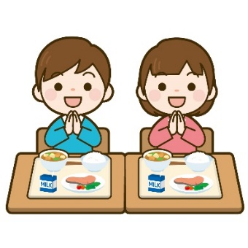At the elementary school, a class is 45 minutes and afterwards it will be 10 minutes break. Students need to check on the class schedule ( JIKAN WARI) and make sure what you need for the next class (text book, notebook, etc).

1. Lunch ( CHUUSYOKU)

School lunch ( KYUSHOKU) will be given from Monday to Friday.

All the students will eat the same food except those who have restrictions.

1. 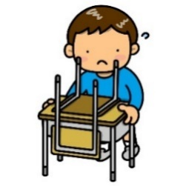Cleaning (　SOUJI)

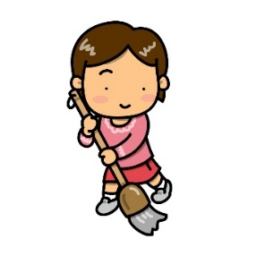Students should clean by themselves the classrooms,

hallway, restrooms, etc. everyday.

1. Meeting before going back home (の　KAERI NO KAI)

Students have a meeting before going back home. Homeroom teacher will inform about the homework, next day’s activities. Students have to take a note on their communication notebook. Please check your son/daughter’s communication notebook at home.

17

Ⅸ. との

MAIN EVENTS AND ACTIVITIES RELATED TO THE GUARDIANS

In Japan, parents/guardians reguraly have a meeting with the class teacher. This is a great opportunity for parents to communicate with the class teacher and get to know how his/her child is doing at school. You can ask anything such as their social skills, problems with bullying (いじめ IJIME), if he/she feels comfortable coming to school or the future of him/her.

1) Home visit by the teachers ( KATEI HOUMON)

During April and May, the class teacher will visit the house of each student. The teacher and parents will have a talk about how he/she is doing at school or home. It is good opportunity for the guardians/parents to get to know the class teacher. It’s about 10 to 15 minutes visit.

2) Parents observation ( JUGYOU SANKAN)

Guardians/parents will come to school and see that his/her child is learning at school.

Please read the letter from the school about the parents observation day and make sure the date and time.

3) Meeting for the Guardians ( HOGOSHA KAI)

This meeting is held to talk about student’s school life. It’s held every semester.

4) Meeting with parents, student and teacher ( KOJIN MENDAN)

This meeting /consult is among parents/guardians, student and classroom teacher. This is a good opportunity to talk about concerns. Classroom teacher will decide the date and time for the meeting/consult. In case if the parents/guardians want to talk to class teacher about something particular, they can ask the teacher to arrange the suitable date and time. Especially, the third year of junior high school is an important grade to choose a career after graduation or apply high school. Please make sure the schedule and be sure to attend a meeting.

5) Lunch box ( OBENTO)

Your son/daughter should bring a lunch box (OBENTO) when they go to a field trip or they participate activities on the weekend. Make a homemade lunch for them if it is possible.

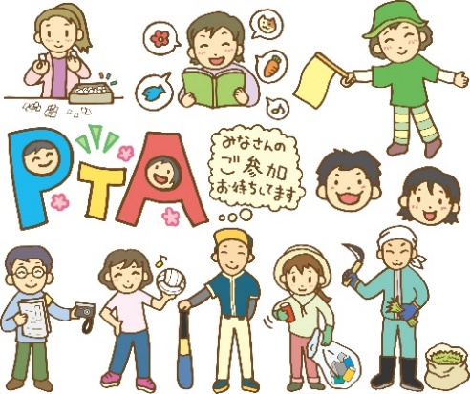6) PTA Activity (PTA　PTA KATSUDO)

There is a group called the PTA (Parent-Teacher Assosiation). This group is in charge of school activities such as “Safety Guidance of School Route”,etc. It is desirable for the parents/guardians to attend PTA activity.

18

Ⅹ. との HOW TO MAKE CONTACT WITH SCHOOL

Example 1- Contact of absence by phone call：

SCHOOL: はい、NAME OF THE SCHOOL です。

A GUARDIAN: GRADE CLASSのLASTNAME です。

1. を します。

SCHOOL: おちください。

TEACHER: はい、　　① です。

A GUARDIAN: NAME OF YOUR CHILDのです、

、どもは 　　 ②　　　のでおみします。

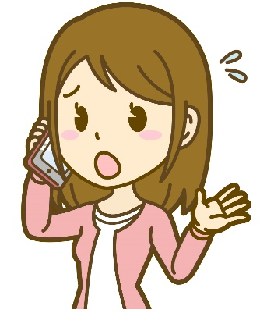TEACHER: わかりました。おに

A GUARDIAN: ありがとうございました。します。

* 1. NAME OF CLASSROOM TEACHER
  2. DIVERSE SYMPTOMSいろいろな

１．が38ありますNETSU GA 38 DO ARIMASU (He/she has a fever of 38 degree.)

２．かぜをひいているKAZE WO HIITEIRU (He/She has a cold.)

３．ちがい KIMOCHI GA WARUI (He/She doesn’t feel well.)

４．けがをしましたKEGA WO SHIMASHITA (He/She got injured.)

５．おなかがい ONAKA GA ITAI (He/She has a stomachache.)

19

Example 2- by communication notebook (RENRAKU CHO)：

1. からのがかれています。：、の、ちなど

Children will write down their homework, the schedule and what to bring for the next day.

1. がみ、サインまたはをおしましょう。

Parents will read and put a sign or stamp (INKAN) on it every day.

1. からのをいて、にえることもできます。：、、、にをませる、

Parents will use a communication notebook to tell the teacher about the absence, being late, leaving school early, taking a medicine after the lunch, etc...

1. にやがあればいてもかまいません。

You may write if there is a question or consultation to the teacher.

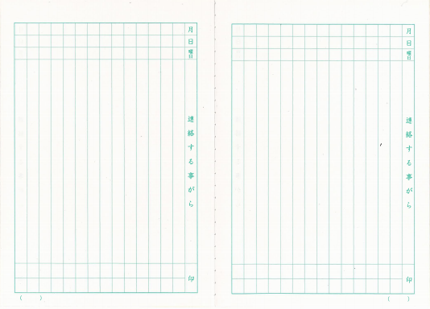

Month

Day

①

③

④

②

20

**いわせ　※のは、まずめにをえましょう。**

**Contact Information ※When you call them, you should tell them what you want to consult first.**

|  |  |  |
| --- | --- | --- |
| content of consultation | consultation place | Phone Number |
| 、、にこと  Regarding public kindergarten, elementary school and junior high school | ＿＿＿市町村　○○課 |  |
| 、こどもにこと  Regarding nursery school and center for early childhood education | ＿＿＿市町村　○○課 |  |

・（「・」）

Telephone and e-mail consultation service

（Entrusted by Ibaraki Prefectural Board of Education “Global support project”)

NPO NPO・　 Ibaraki NPO Center Commons

TEL：**070-2303-7416**（/Japanese）／**070-2303-7408**（/English・/Portuguese・/Tagalog）

E-mail：　[global@npocommons.org](mailto:global@npocommons.org)　　～ (Monday – Friday) 10: 00am ~ 17: 00pm

参考・関連リンク集　　Reference and Related Links

①「のための」(2015年4月発行)

Ministry of Education, Culture, Sports, Science and Technology

"School Attendance Guidebook for Foreign Students"　(Published in April 2015)

https://www.mext.go.jp/a_menu/shotou/clarinet/003/1320860.htm

②ＮＰＯ・ Ibaraki NPO Center Commons

「PRE-SCHOOL」(2020) “PRE-SCHOOL”

「ののための」(2019) “Guidance for International Residents”



<http://peer-joso.com/cn2/documents.html>

③　Ibaraki Prefectural Board of Education

「　ひよこ」 0～5のをもつ

“Parents handbook HIYOKO(chick)” For parents with 0 ~ 5 year old children

「　」～4のをもつ

“Parents handbook KURO-BA-(clover)” For parents with preschool

~ fourth grade of elementary school students

「すくすくて　いばらきっ」から

Please access to the home education support "SUKUSUKU SODATE IBARAKIKKO".