Ⅶ. 小学校で必要な物 Things you need at elematary school
お子さんが小学校へ入る事が決まったら、学校生活や学習に必要な準備をしましょう。
下記を参考にしてお子さんの学校に合わせて準備して下さい。
Buy school supplies before the school starts. You can see standard school supplies which is listed below. But please confirm with your school what you exactly need to buy.
a) 服装と持ち物 Clothes and belongings
- 服装：あまり華美にならないような動きやすい服装、体育のある日に体操服を使います。 学校によっては制服があります。
Clothes: Wear comfortable clothes that are not too flashy. When it is P.E class, students will change to TAISOU FUKU (gym clothes). Some schools have school uniform (SEIFUKU).
- 赤白帽 Red-white cap (KOHAKU BOUSHI or AKASHIRO BOUSHI)
- 上履き入れ Bag for indoor shoes (UWABAKI IRE)
- 上履き Indoor shoes (UWABAKI)
- 運動靴 Sports shoes (UNDOUGUTSU) 学校へ行く時は走りやすい運動靴を履きます。
When students go to school, they wear this sports shoes.
- 名札 進級時や紛失した時は買う。入学式の日に配布されます。
Name tag (NAFUDA) will be given at the day of the entrance ceremony.
When you lost it, you have to buy a new one.
- ランドセル School backpack (RANDO SERU) Some schools specify the color and/or shapes.
- 手提げ school bag (TESAGUE BUKURO)

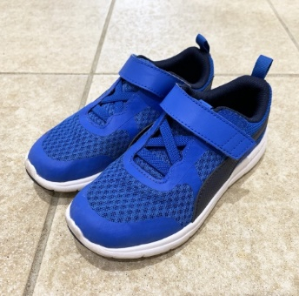
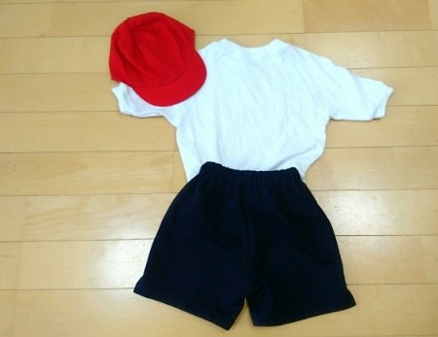
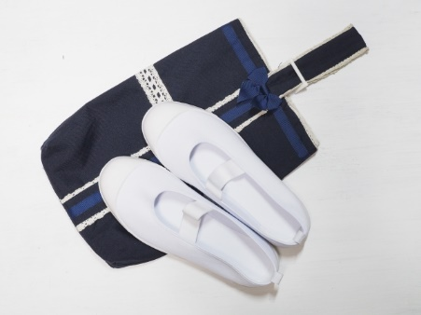
③
②
①
⑤

②
②

④

②

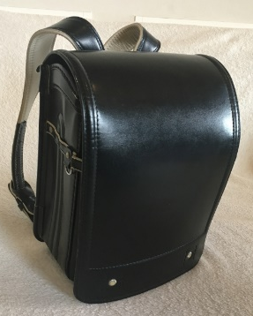
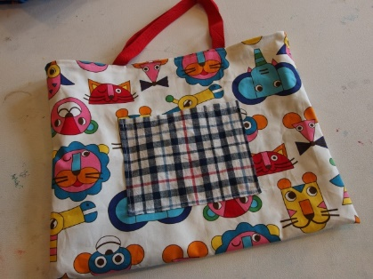
⑦

②
⑥

②
⑧

②
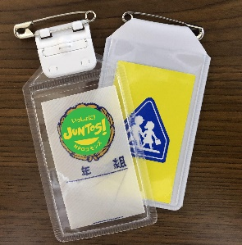

一般的にピアス・パーマ・化粧は禁止されています。
Generally, wearing earrings, getting a perm, and makeup are not allowed.
ヒジャブなどの宗教的な配慮等が必要な場合は、学校に相談してください。
If you need religious consideration such as hijab, please tell to the school.

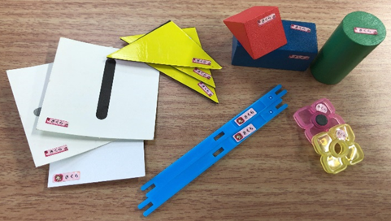
b) 学用品 School Supplies
- 各教科書は無償配布されています。
Textbooks (KYOUKASHO) are free.
- 各科目のノート Notebooks for each subject
算数セット Arithmetic tool box (SANSUU SETTO)
一つ一つすべてに記名します。市販の専用シールを文具店やオンラインストアで注文すると便利です。
Write your child name on all of them. It is convenient to order name stickers at the stationary store or online store.
文房具（筆箱、鉛筆、消しゴム、定規 など） Stationary：pencil case, pencils, erasers, rulers, etc.
お道具箱（はさみ、のり、セロテープ、ホッチキスなど）Stationary box：scissors, glue, scotch tape, stapler, etc.
給食セット（ナプキン、スプーン、はし、マスク）
Lunch set (KYUSHOKU SETTO)：table napkin(NAPUKIN), spoon, chopsticks(HASHI), mask(MASUKU)
歯ブラシ、コップ、巾着袋: toothbrush(HABURASHI), cup(KOPPU), bag for the cup(KINCHAKUBUKURO)
ピアニカ Pianica (PIANIKA)
絵の具セット Painting set（ENOGUSETTO）
連絡帳、連絡袋Communication book(RENRAKUCHOU), Bag for communication book(RENRAKUBUKURO)
※新学期にクラスでまとめて買う事ができる物もあるので、学校のお知らせを読むようにして下さい！
You might order some school supplies at the school. They will give you an order sheet, so please make sure to read all letters from the school！
